Renewing your ODTUG Membership
Log into ODTUG and hover over My Options
↓
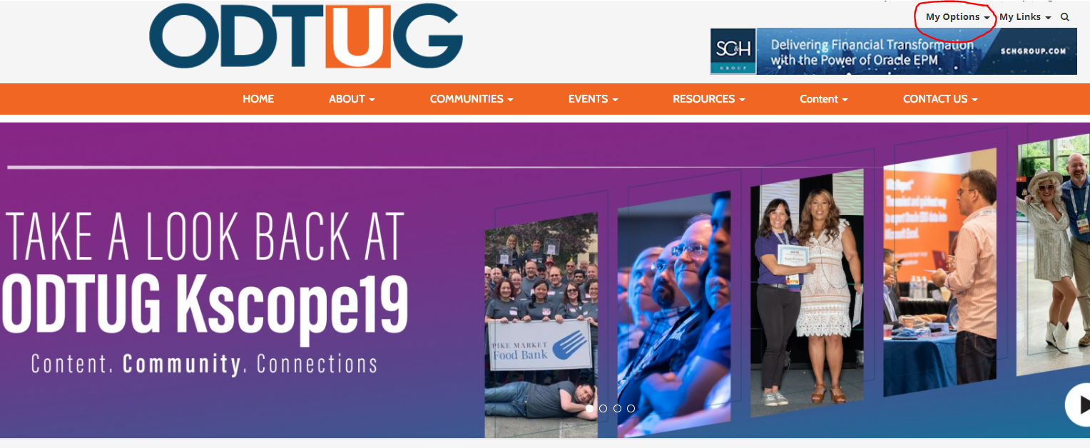
From there, choose the My Profile option
Once in your profile, there is a “More” tab on the left side of the page (the one with three dots).
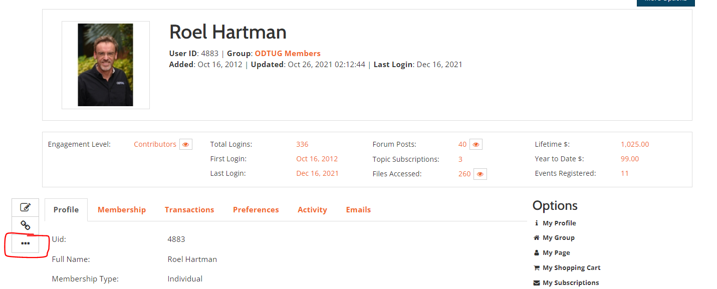

Click on the three dots and then choose Renew Membership from the drop-down menu.
This will begin the Start User Membership Renewal process. Follow the prompts and ensure your stored information is accurate in the fields provided. Once confirmed, you will be brought to the Invoice. The invoice may be paid by credit card online, by check or by third party. All options are available by scrolling down to the bottom of the invoice. You also have the option to Email Invoice and Download Invoice PDF.
If you have any questions or need additional help, please contact Cyndi Nickerson at cyndi@odtug.com
ODTUG appreciates your membership renewal!

