Upgrade from Associate Membership to Individual Membership
If you are already an ODTUG member you can upgrade your membership without creating a new account!
Log into ODTUG and hover over My Options
↓
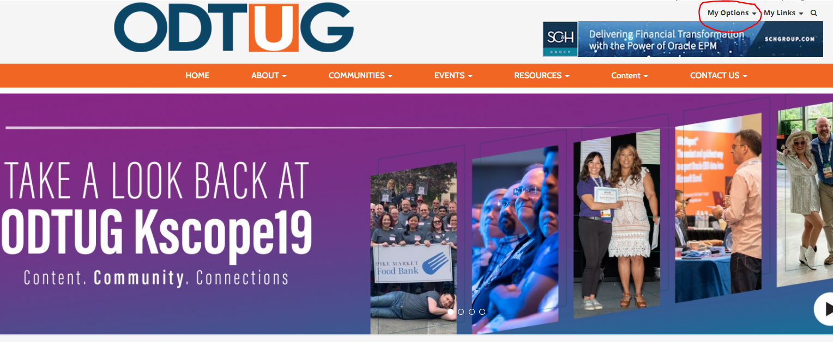
From there, choose the My Profile option
Once in your profile, there is a “More” tab on the left side of the page (the one with three dots).

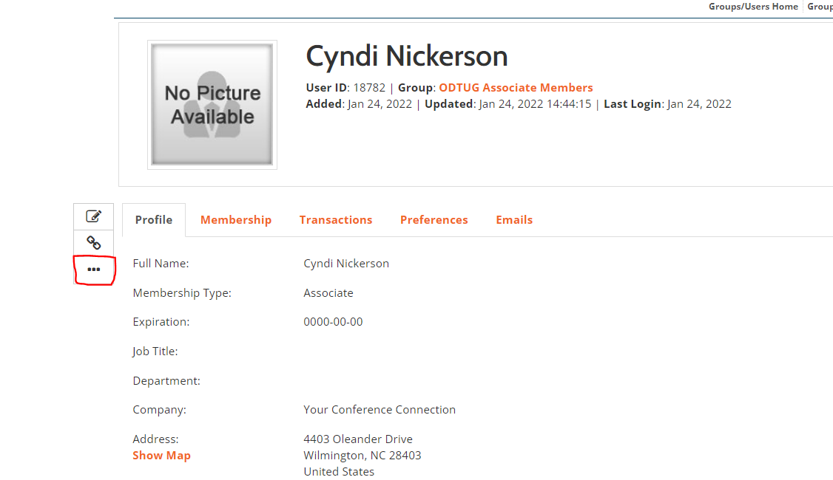

Click on that and then choose Add Individual Member from the drop down menu.

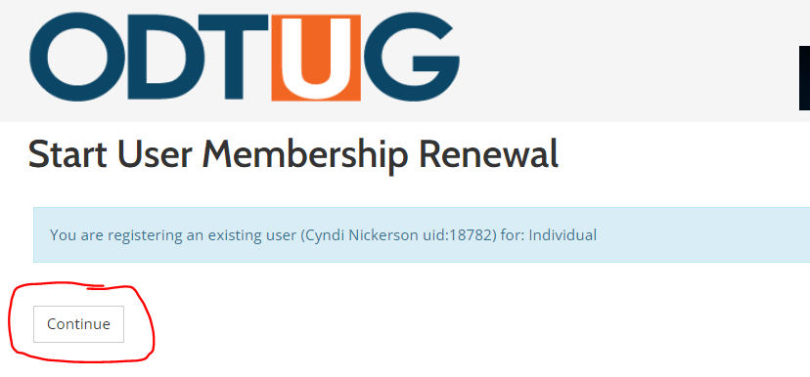

Click Continue and ensure your stored information is accurate in the fields provided. Once confirmed, scroll to the bottom of the page and click OK. You will then be brought to Membership Type and Pricing. If you do not have a discount code, click OK to proceed.

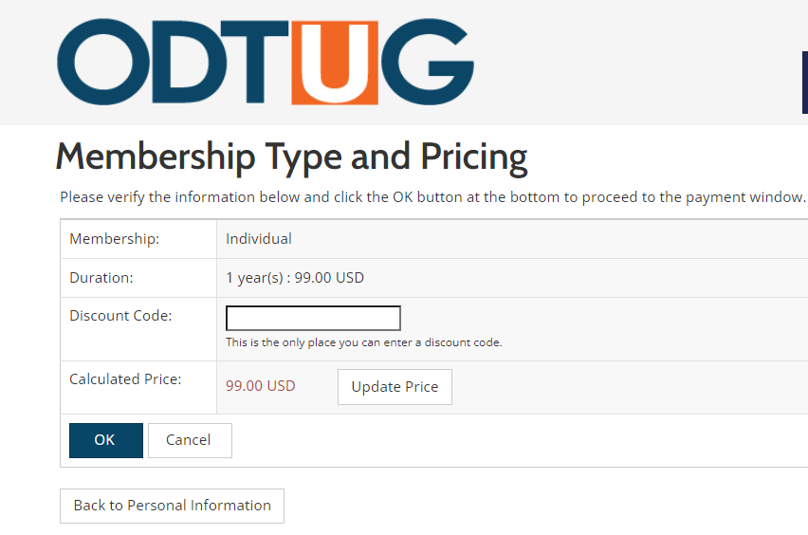

This will bring you to your invoice. The invoice may be paid by credit card online, by check or by third party. All options are available by scrolling down to the bottom of the invoice. You also have the option to Email Invoice and Download Invoice PDF.
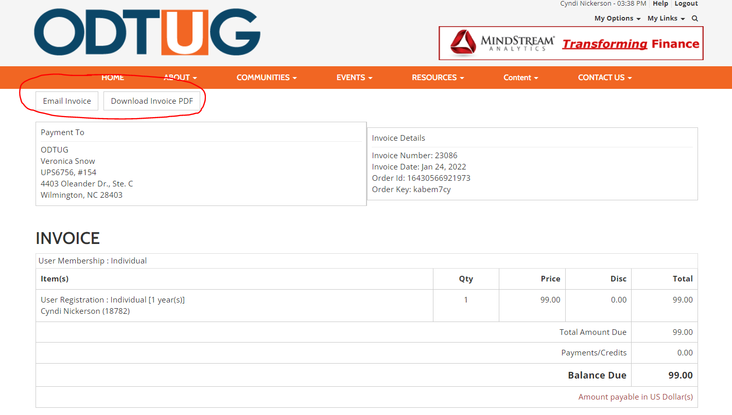

If you have any questions or need additional help, please contact Cyndi Nickerson at membership@odtug.com
Welcome to ODTUG!

